Startup Funding Success Probability Analysis
1. Problem Statement
Thousands of startups are launched every year, but only a small percentage successfully secure funding. Investors and startup accelerators need data-driven methods to identify factors that influence funding success. This project aims to analyze startup data using statistical and probability techniques to understand patterns associated with successful funding outcomes.
2. Dataset Description
The dataset contains information about startups, including:
- Startup Name
- Industry
- City
- Team Size
- Founder Experience
- Startup Age
- Revenue
- Growth Rate
- Funding Status
The target variable is Funding Status, which indicates whether a startup received funding or not.
3. Data Cleaning and Preparation
The following preprocessing steps were performed:
- Loaded the dataset into Python using Pandas.
- Checked data types of all variables.
- Handled missing values.
- Removed duplicate records.
- Verified dataset consistency before analysis.
4. Descriptive Statistical Analysis
Statistical measures such as Mean, Median, Standard Deviation, Quartiles, and Percentiles were calculated.
Key Findings
- Average Team Size: 145
- Average Founder Experience: 20
- Average Startup Age: 8
Funded startups generally showed higher founder experience and better growth indicators compared to non-funded startups.
5. Probability Analysis
Probability calculations were performed to estimate funding success under different conditions.
Examples
- Probability of AI startups receiving funding.
- Probability of startups with more than 5 years of founder experience receiving funding.
- Probability of funding based on city.
- Probability of funding based on growth rate.
Findings
The analysis showed that startups with experienced founders and higher growth rates had a greater likelihood of receiving funding.
6. Relationship Analysis
Several relationships were analysed using visualizations and statistical techniques.
Variables Investigated
- Founder Experience vs Funding
- Team Size vs Funding
- Revenue vs Funding
- Growth Rate vs Funding
- Industry vs Funding
Visualizations
- Correlation Heatmap
- Industry-wise Funding Chart
- Founder Experience vs Funding Plot
- City-wise Funding Analysis
(Insert Screenshots Here)
7. Hypothesis Testing
Null Hypothesis (H₀)
Founder experience does not influence funding success.
Alternative Hypothesis (H₁)
Founder experience significantly influences funding success.
A T-Test was performed to compare founder experience between funded and non-funded startups.
Result
- P-Value: 0.3037

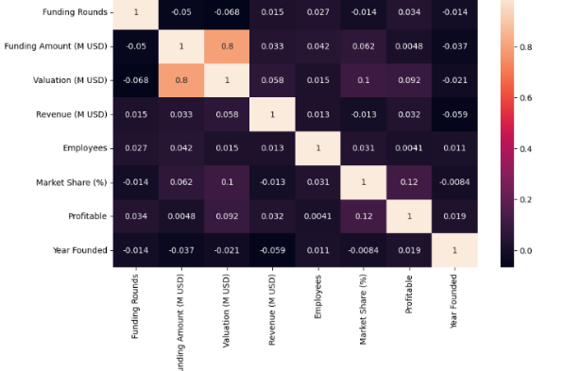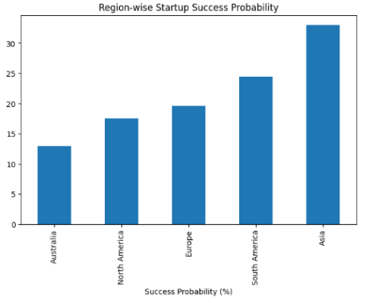
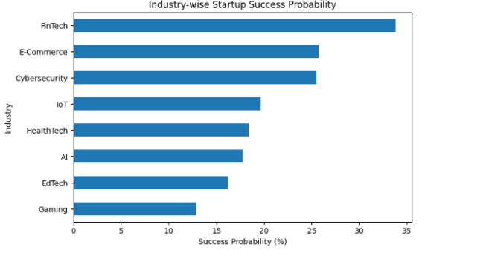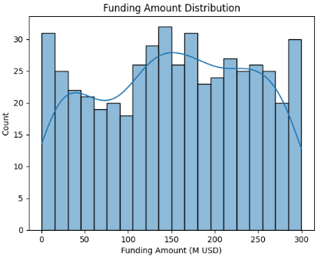

Interpretation
If the p-value is less than 0.05, the null hypothesis is rejected, indicating that founder experience has a significant impact on funding success.
8. Startup Segmentation
Startups were grouped into different categories:
High-Growth Startups
Startups with high growth rates and strong market traction.
Early-Stage Startups
Newly established startups with limited operational history.
Experienced Founder Startups
Startups led by founders with significant industry experience.
Revenue-Driven Startups
Startups generating strong revenue compared to peers.
The funding success rate was compared across these segments.
9. Business Insights
Key Factors Influencing Funding Success
- Founder Experience
- Revenue Performance
- Growth Rate
- Industry Type
Industries Attracting More Investment
- Artificial Intelligence (AI)
- FinTech
- HealthTech
Founder Experience Advantage
Startups led by experienced founders demonstrated higher funding success rates.
High-Potential Startup Segments
- High-Growth Startups
- Revenue-Driven Startups
- Experienced Founder Startups
10. Recommendations
Based on the analysis:
- Investors should prioritize startups with experienced founders.
- High-growth startups should receive special attention.
- Revenue-generating startups present lower investment risk.
- Industry trends should be monitored regularly for investment opportunities.
- Data-driven evaluation methods should complement investor intuition.
11. Conclusion
This study used statistical analysis, probability calculations, visualization techniques, and hypothesis testing to identify factors associated with startup funding success. The findings suggest that founder experience, growth rate, revenue, and industry type play important roles in attracting investment. These insights can help investors and startup accelerators make more informed funding decisions.

Interpretation
If the p-value is less than 0.05, the null hypothesis is rejected, indicating that founder experience has a significant impact on funding success.
8. Startup Segmentation
Startups were grouped into different categories:
High-Growth Startups
Startups with high growth rates and strong market traction.
Early-Stage Startups
Newly established startups with limited operational history.
Experienced Founder Startups
Startups led by founders with significant industry experience.
Revenue-Driven Startups
Startups generating strong revenue compared to peers.
The funding success rate was compared across these segments.
9. Business Insights
Key Factors Influencing Funding Success
- Founder Experience
- Revenue Performance
- Growth Rate
- Industry Type
Industries Attracting More Investment
- Artificial Intelligence (AI)
- FinTech
- HealthTech
Founder Experience Advantage
Startups led by experienced founders demonstrated higher funding success rates.
High-Potential Startup Segments
- High-Growth Startups
- Revenue-Driven Startups
- Experienced Founder Startups
10. Recommendations
Based on the analysis:
- Investors should prioritize startups with experienced founders.
- High-growth startups should receive special attention.
- Revenue-generating startups present lower investment risk.
- Industry trends should be monitored regularly for investment opportunities.
- Data-driven evaluation methods should complement investor intuition.
11. Conclusion
This study used statistical analysis, probability calculations, visualization techniques, and hypothesis testing to identify factors associated with startup funding success. The findings suggest that founder experience, growth rate, revenue, and industry type play important roles in attracting investment. These insights can help investors and startup accelerators make more informed funding decisions.

